University of Development Alternative

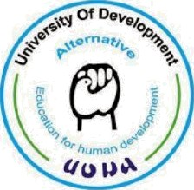

**Assignment On**

**Necessary organic compounds for the preparations and treatment of medicine of COVID-19**

**Course: Pharmacology (I)**

**Submitted To:**

**Mirza Nipa Monalisa**

Assistant Professor

University of Development Alternative.

**Submitted By:**

**Jannat Ara Jaren**

ID: 031211005

Semester: 4th

Department: Pharmacy

Batch: 62

**Submission Date: 21.02.2022**